Abstract

A study of paramedics’ attitudes to the effects of
speed humps on resuscitation of patients en route
to hospital, including general patient care and
ambulance response times

MARK BELCHAMBER

“A dissertation submitted in partial fulfilment of the requirements for the BSc (Hons) Paramedic Science at the University of Hertfordshire, Hatfield, Hertfordshire.”

May 2003

Abstract
Traffic calming devices have been installed and speed reducing measures have been implemented on roads in a bid to increase road safety and reduce traffic related deaths and injuries. Whilst at first glance this is a wholly laudable endeavour, most of these measures cannot be selective in which types of traffic they hinder.

A small number studies have been conducted surrounding how speed restrictions affect buses, lorries, cars and motorcycles, but there is very little evidence to assess the impact that these restrictions have on emergency ambulance services. In the United States there has been a small amount of research utilising paramedic fire engines, however no practical British research has been undertaken. No studies have been conducted on the way paramedics perceive and react to speed calming measures in day to day activities.

Anecdotal evidence suggests that paramedics dislike speed restrictions and actively avoid them in some circumstances – however, the impact that these actions have on patients and patient care is not documented. This study investigates the attitudes and perceptions that paramedics have to one type of speed restriction – the continuous (i.e. not split) speed hump.

A questionnaire was constructed and, following pre testing, sent or given to a purposive sample of 100 paramedics; the anonymous questionnaire was predominantly quantitative with some qualitative elements - 36 questionnaires were returned.

Data were obtained on attitudes and opinions to speed humps relating to the following: ‘999’ and ‘urgent’ calls; routes to a hospital or other receiving facility with different types of patient; efficacy of cardiopulmonary resuscitation (CPR); ability to perform medical interventions; and various patient conditions and experiences.

Using descriptive statistics to analyse the data, it was discovered that 24 of 36 paramedics (66.6%) would deviate routes to avoid speed humps en route to a 999 call and 18 of these were willing to add an average of 2.5 minutes to the response time. 20 of 36 paramedics (55.6%) would deviate routes to an ‘urgent’ call for their own comfort, and 14 of those would extend time of arrival to the patient by up to 10 minutes. En route to hospital, 28 of 35 paramedics (80%) would alter the route with a medically stable patient, 20 of 34 (58.8%) with a medically unstable patient (adding an average of 3.8 minutes) and 18 of 34 (52.9%) with a patient in cardiac arrest (adding up to 5 minutes). 32 of 36 of paramedics (88.9%) felt that speed humps interfered with their CPR, 13 of 33 (39.4%) felt that that was to the detriment of their patient.

17 of 36 paramedics (47.2%) elected not to undertake a medical intervention as a result of travelling over speed humps, 14 of 27 (51.9%) of whom felt that that intervention was essential to improve the patient’s condition. All respondents felt that a number of patient conditions were affected detrimentally by speed humps, the most common conditions being spinal or back injuries and fractures generally.
List of Contents

Section Page Number

List of Figures v

Acknowledgements vii

Introduction 1

Critical Review of the Literature 3

Research Design and Methodology 11

Presentation of Results 19

Discussion 39

Conclusions and Recommendations 53

Appendices 57

Appendix 1: Further acknowledgements 58

Appendix 2: Literature searching methods 59

Appendix 3: Ethics 61

Appendix 4: Questionnaire pack 67

Appendix 5: Pre test results 74

List of References 75

Bibliography 77

List of Figures

List of Figures Page Number

Figure 1: Number of calls per shift (average) 19

Figure 2: Number of calls per shift (average) using humped roads 19

Figure 3: Graph showing how many people stated they would 20
take an alternative route to a 999 call (avoiding humps)

Figure 4: Graph showing how many people would take an alternative 20
route to an urgent (non blue light) call (avoiding humps)

Figure 5: Number of extra minutes considered acceptable to a 21
999 call to avoid road humps

Figure 6: Number of extra minutes considered acceptable to an 22
urgent call to avoid road humps

Figure 7: Reasons given for avoiding road humps en route to 23
a 999 call

Figure 8: Reasons given for avoiding road humps en route to 24
an urgent call

Figure 9: Graph showing how many people would take an alternative 25
route to a hospital (avoiding humps) with a stable patient

Figure 10: Number of extra minutes acceptable to arrive at hospital 25
with a stable patient to avoid road humps

Figure 11: Reasons given for avoiding road humps with a medically 26
stable patient en route to hospital

Figure 12: Graph showing how many people would take an alternative 27
route to a hospital (avoiding humps) with an unstable patient

Figure 13: Number of extra minutes acceptable to arrive at hospital 27
with an unstable patient to avoid road humps

Figure 14: Reasons given for avoiding road humps with a medically 28
unstable patient en route to hospital

Figure 15: Graph showing how many people would take an alternative 29
route to a hospital (avoiding humps) patient in cardiac arrest

Figure 16: Number of extra minutes acceptable to arrive at hospital 29
with a patient in cardiac arrest to avoid road humps
List of Figures Page Number

Figure 17: Reasons given for avoiding road humps with a patient in 30
cardiac arrest en route to hospital

Figure 18: Graph showing how many people feel CPR performance 31
was affected detrimentally by speed humps

Figure 19: Reasons given for believing CPR was affected whilst 31
driving over road humps

Figure 20: Graph showing how many people feel CPR performance 32
affected detrimentally by humps caused a different
patient outcome

Figure 21: Reasons given for believing a patient in cardiac arrest 32

undergoing CPR over road humps had a different patient

outcome than CPR not over road humps

Figure 22: Reasons given for NOT believing a patient in cardiac 33

arrest undergoing CPR over road humps had a different

patient outcome than CPR not over road humps

Figure 23: Specific patient conditions that are believed to be affected 34
detrimentally by road humps

Figure 24: Graph showing how many people have ever elected not 35
to undertake a procedure due to road humps

Figure 25: Procedures that have not been undertaken as a result of 35
travelling over road humps

Figure 26: Graph showing how many procedures not undertaken 36

due to road humps have ever meant a drop in patient care

Figure 27: Graph showing how many procedures not undertaken due to 36

road humps were deemed essential

Figure 28: Graph comparing extra time permissible to avoid 37

road humps

Figure 29: Number of patients who have commented on speed 38

humps while in an ambulance

Figure 30: Comments made by patients to crews regarding road humps 38

Acknowledgements

I would like to express my gratitude to all those who have assisted and encouraged me throughout this research, in particular the following people who have been especially influential:

The London Ambulance Service for funding my time and study leave to undertake the research;
Indra Jones - my research supervisor at The University of Hertfordshire for her help advice and support;
Julia Williams for her tutelage and support;
Rachael Donohoe and the team at LAS Clinical Audit and Research for their advice, time and use of facilities;
My class colleagues at the University of Hertfordshire who offered their suggestions and ideas at various points;
Finally all those who responded by returning the questionnaires and without whom there would have been no data!

Further people I wish to thank and acknowledge are named in Appendix 1

Introduction

Traffic calming measures have been significantly highlighted by successive governments as necessary, responsible and life saving (Chope 1991, Brake 1997) – tenets which do not appear to be in tension with the ethos of any ambulance service. However, whilst at first glance the calming and slowing down of traffic seems reasonable and sensible, it does present problems for specific groups of road users, not least the emergency ambulance services.

The European Resuscitation Council Guidelines have been used in the Government’s NHS Plan (2000) and state that for every one minute of delay in definitive treatment a patient experiences whilst suffering a myocardial infarction, 11 days of his/her life are lost. Extrapolated, this means that 1 year of that patient’s life is lost for every 30 minutes of delay. In patients suffering from other time critical conditions or injuries, delays can also mean the difference between full recovery and partial recovery (CVA framework); or in extremis between partial recovery and death ( e.g. unstable airway problems). The current British Government has taken the issue of heart disease so seriously that it has allocated treatment requirements for the National Health Service as a whole in the National Service Framework for Coronary Heart Disease (1998). The impact on ambulance services is set out in the document and requires them to assist in conveying patients from the 999 call to a thrombolytic treatment (“door to needle time”) in 30 minutes.

This “door to needle” time is recorded from the time a patient dials 999 and clearly the speed with which an ambulance responds has a large impact on whether the patient will then reach an appropriate centre of care within 30 minutes. Any and all influences on the ambulance journey to the patient’s home and then to the receiving hospital will directly affect patient outcome.

This research will demonstrate how paramedics perceive key problems encountered by emergency response vehicles, specifically those caused by traffic calming speed cushions. By accessing research from the United States (there is very limited U.K. based pre-hospital research) it will be shown that speed cushions affect ambulance response times both on ‘blue light’ and standard driving. The effect that this has on patient care will be explored, together with the implications of patient comfort whilst travelling in an ambulance going over speed cushions. It will also encompass the safety and willingness of paramedics to intervene on ‘humped’ roads and the efficacy of those interventions.

There are many different types of speed restricting device: due to the time and resources available, this research will explore the impact of the introduction of the single continuous humped type of speed cushion. It will investigate:

- how traffic calming measures, specifically speed cushions, are perceived by paramedics to have an impact on emergency and ‘urgent’ ambulance responses;
- how patient treatment is impacted by the feasibility for paramedics to intervene medically en route to hospital when travelling over speed cushions.
- The impact speed humps have on resuscitative efforts.

Critical Review Of The Literature

There is a significant lack of literature surrounding the issue of road humps and their effect on emergency ambulance services, however the literature review examines material published predominantly in the last seven years, including British and American studies for comparison. Literature searching was undertaken using a variety of computerised databases, manual library searches and internet search engines. Personal correspondence was sought with borough councils, other emergency service representatives and ambulance service personnel from various trusts. Full details of searching procedures can be found at Appendix 2. Despite much searching in both real and virtual libraries, the amount of literature available to the pre-hospital researcher on this topic is minimal. Indeed up until 2002 there were no U.K. based studies concerning the direct impact on any emergency response vehicles, although at the time of writing there is a practical study of the effect of speed humps on various emergency vehicles being undertaken at Millbrook Proving Ground Ltd, Bedford. Searches on (among others) Medline, CINAHL, and Voyager using the keywords ‘Traffic calming’, ‘Sleeping policemen’, Road Safety, ‘Speed humps’, ‘Speed cushions’, ‘Speed tables’ and ‘Thumps’ provided no U.K. based evidence and, when also linked with ‘Emergency’, ‘Pre-hospital’ and ‘Ambulance’, showed no relevant literature was available. Even anecdotal journals and enthusiasts’ web sites contained only unsubstantiated claims concerning the effect of speed humps on emergency vehicles.

Studies on the general affects of speed humps on normal traffic (including motorcycles with and without sidecars) have been undertaken by bodies such as the Transport Research Laboratory (TLR) and the Department of Transport, Environment and the Regions (DETR). The majority of these studies concentrate on different styles of road hump and normal average driving discipline i.e. not whilst driving on blue lights. Although the DETR document ‘Speed Cushions’ (1994) does relate a test undertaken by an ambulance over different types of cushion, a study of times with and without cushions was not found. The results of the DETR’s research showed a trend towards a decrease in speed of vehicles of up to 7 mph over various types of hump, but there was complete deficit of information comparing humped roads to those without humps – nor were the attitudes and perceptions of those undertaking the test commented upon.

There have, however, been some studies in America that have begun to address some of the issues surrounding the ways that traffic calming can impact upon emergency response vehicles. In the United States, only 3 studies were identified and these are dominated by fire engines by virtue of the fact that paramedic (EMS) personnel are also fire crew; therefore a direct comparison is not possible with a U.K. ambulance service. Encouragingly there are reports in America that show the attitudes of EMS personnel and managers to speed humps despite a lack of evidence and research in this area. Even though they are emotive and reactionary in some circumstances, they do serve to highlight certain issues and attitudes surrounding traffic speed humps.

A study conducted by the Montgomery Fire and Rescue Commission (1997) in Maryland tested the ability of fire engines to maintain a self imposed standard of 5 minutes ‘charter time’ (1½ minutes dispatch, 3½ minutes travelling). 12 test runs (drives) were conducted per vehicle (including an ambulance) over 3 standard speed humps distanced at 12 feet apart. It was found that the delays over the humps ranged between 2.8 seconds and 7.3 seconds per hump. Four vehicles averaged less than 20 mph over the humps, whereas a similar stretch of road unimpeded saw a speed of 35-40 mph safely achievable. It was then calculated that the area capable of being served within 5 minutes fell from 2 miles to 1.3 miles – or that each road hump was ‘worth’ 0.5 of a mile in distance. The study did not make it clear how impartial the timekeepers and participants were in the course of the study and again the opinions and comfort of those involved are not explained. It was, however, a quantitative study that had a stated intention of studying the effect of speed humps and traffic circles on response times. It appeared to have clear goals and test criteria, but it did not mention any tests of validity prior to obtaining results. Lincoln and Guba (1995) state that any test whose rigour has not been tested cannot expect to have the same credence as one that has; whilst this does not invalidate the study’s findings, a pre-test serves to confirm the authority of data obtained. No pilot study appears to have been undertaken which, Polit and Hungler (1999), say is a wise precaution in order to test the tools and research instruments - and it does not appear that this was acknowledged by the researchers in this instance.

Additionally, the structure of the tests does not appear to have been based on any previous research. Understandably, the dearth of anything other than anecdotal information even in America made this difficult, however, the consequence of this is that a hypothesis could not emerge from an existing knowledge base – it had to emerge from a deductive approach (Walsh 2001). To counter this, the study does present its findings clearly and rationally - and conclusions, where drawn, are put into a context of developing research. The research cannot have a significant basis in existing knowledge, rather it is exploratory and is liable to towards the anecdotal (Walsh 2001). The study does attempt to remain unbiased whilst using existing preconceptions. The study concludes that humps do indeed delay emergency vehicles, although it acknowledges that ‘test’ conditions do not replicate ‘road’ conditions.

Further assertions from California by Chico City Council (http://www.motorists.org/issues/engineering/battling_traffic_calming.html 6th January 2003) are made to the effect that speed humps are only effective immediately before and after the hump – that the average speed of normal road vehicles remains unchanged. Although unsubstantiated, claims are made that the effect to emergency vehicles is that of increasing emergency call times by 15 seconds per hump. Whether or not this is true, emergency workers are on record as saying that they hated speed humps. This is reinforced by the Letter Report by Berkeley, California, Fire and Emergency Services Department (1995) that indicates that spinally injured patients have had their conditions deteriorate, even at greatly reduced speeds over road humps. Additionally EMS workers indicated that commencing IV therapy (described as literally life saving) was very difficult, if not impossible over road humps and that patient care could be potentially severely compromised. The report continues giving statements from emergency workers to the effect that performing extended skills procedures on a road with humps is not safely possible and further asserts that suspension damage to vehicles and difficulties in mass casualty situations could easily occur. Although no independent substantiation of the above is offered and the reports appear to have been funded internally, there is no apparent conflict with the available literature. This is also the case in a narrative and unreferenced report from Sacramento, where fire engines could not exceed 15 mph over speed humps in the county.

The City Council of Boulder, Colorado (1997) report conducted a comprehensive study as part of their traffic mitigation programme that examined and compared emergency response times before and after the implementation of the programme. This was cross referenced with traffic accident deaths and cardiac arrest emergencies and survivals. From this it was extrapolated that emergency responses suffered a 14% delay over areas of the city where humps were installed, resulting in up to 1 minute of delay on some journeys. This equated to 8½ deaths per year due to increased travelling times from road humps, whereas only 2.8 traffic deaths occurred per year – indicating that traffic calming measures may actually cost lives overall.

Further studies in Austin, Texas, showed an increase in travel time of 100% in some areas (Bunte 2000). Moreover, examples were given of four EMS workers suffering spinal injuries as a direct result of travelling over speed humps and other examples of less severe injuries were documented. It is interesting to note that in Malibu, California, the Director of Public Works is an advocate of speed humps but, in his August report (1995), he acknowledged that emergency drivers had to slow down excessively over road humps - thus increasing response times, and that excessive jerking of vehicles was encountered. Other counties claim variously that speed humps actually cause heart attacks due to the anxiety and discomfort they cause to patients. Again no studies have been officially conducted and the opinions and attitudes of the EMS workers are reflected, but it is relevant to record those feelings as they may have an impact on the way that they undertake their professional duties – or at least how they perceive themselves doing so. Cole (1996) states that the way a job or task is undertaken has a direct relationship with how the individual undertaking that task performs. If an individual feels satisfied in him or herself that all the tools required are in place and s/he is being supported or assisted in the best way possible, then performance of the task will be optimal. Contrarily if that individual feels insecure, endangered or uncomfortable with any aspect of a task, that task will be performed less than satisfactorily. The degree to which the task is under performed depends on how that individual copes with the perceived lack of necessary materials/support etc. and it is the perception to the individual that is the important factor. In this context, an emergency worker who believes that a speed hump is affecting his or her practice will likely not perform to the optimum standard.

The flowing examples emphasises this point: in Clovis, California, emergency vehicles consciously avoid all streets with speed bumps unless the emergency is on that humped street, a practice copied by crews in Eugene, Oregon. In Santee (San Diego) fire workers state that they never arrive at their destination within the specified time over road humps and in Princeton, New Jersey the squads are concerned by their slowed response times.

Canadian emergency crews all agreed that they have been impeded by speed humps and are concerned that it is only a matter of time before the delays caused result in serious consequences.

Only a handful of British references can be found that address these issues – none of which offer any evidence. Again there is a certain amount of reported speech and vocalising of opinions (a North Yorkshire Ambulance Service Divisional Officer is on record as saying that road humps have ‘cost’ 2 minutes to an average 999 response), but no official research based evidence. Jones (2001) in an article on speed humps for the Financial Times, reported that medics called for a ban on them because of a rising number of back injuries amongst passengers and Clement (1995) states that Chief Fire Officers and the ambulance service are generally against the use of humps due to the additional delay in responding to emergencies – a claim reiterated by the Campaign Against Road Hump Madness in Haringey, London.

Recently in the House of Commons it was stated that there had been no evaluation of the medical effects of road humps on patients being transported by ambulance (Bassetlaw 2002). Chapman (2000) wrote of anecdotal evidence from North Yorkshire Ambulance Service that indicated an increase of at least 2 minutes to the national ambulance response standard set by the Operational Research Consultancy (ORCON). Even the Department of Transport and Royal Society for the Prevention of Accidents have not chosen to undertaken any definitive research. The London Ambulance Service’s findings are that the area an ambulance can reach within its target response time diminishes at a rate that is the square of the speed of reduction (Reinton, personal communication). If road speeds reduce by 11% (as they have at peak times in London over 5 years), the area that can be reached within a set time shrinks by 20% - or 25% more ambulances for the same cover are needed. Off peak the speed reduction is 17%, coverage reduction 34% and another 42% ambulances are required (Reinton, personal communication). Clearly, if speed humps are shown to increase response times, they are contributing to, not detracting from, an already serious problem.

Conclusion
In summary it can be seen that literature on studies surrounding the impact of any kind of speed restrictions on emergency vehicles remains extremely sparse. Studies surrounding the perceptions of emergency workers to speed humps, and their reactions to them in the ambulance whilst on the way to a call, or treating a patient on the way to a receiving hospital, is similarly lacking. However, anecdotal evidence and opinions have been expressed publicly and there is no reason to suggest that, purely because most of this appears to be from the United States, similar types of opinion do not exist in the United Kingdom.

It can be seen from the literature review that very little ratified evidence of speed hump influences in the pre-hospital arena exists, and such literature that is substantiated refers to emergency services dissimilar to those in the United Kingdom. Principles and trends can clearly be identified from all the articles, and personal opinions from those in the pre-hospital arena appear to agree that speed humps have a detrimental effect on response times and patient care/patient outcomes. Consequently there is a gap in the research which, if not filled, may continue to affect patients adversely. This research will identify the nature of the impact of road humps but the primary intention of the proposed research is not to change current restrictions, but to perhaps influence other (as yet unmade) decisions on traffic calming measures and their appropriateness – although changes to existing measures must be induced by correct research and therefore the research may induce change.

Research Design and Methodology

Overview and Justification of Design and Methodology
Due to the lack of research in the area being studied, it was decided to use a systematic, quantitative approach. Polit and Hunger (1995) state that this is most suited to systematically collecting numerical information using a structured formal tool, however, the study contains both qualitative and quantitative elements. This is beneficial for a number of reasons, including the fact that the two types of data can complement each other and enhance the appreciation of the research problem and the validity of the results. Additionally it can identify areas where further investigation would be beneficial as well as allowing the qualitative aspects of the study to complement and elaborate on the quantitative aspects, and allow these to be seen in a broader context.

As this study is not preceded by any U.K. research it is not possible to build on any, however, the American studies have been accessed as far as possible to assist in the design of the research tool. Given the time scales and level of research, the research is unlikely to be so significantly definitive that it causes an immediate change in policy, for example, council policies in relation to ambulances. Instead, this is intended to be a piece of research that can be built upon later by other individuals or agencies.

A questionnaire was selected as the most appropriate tool for the research in view of the considerations needed for time available, scope of resources and level of research. Additionally, Polit and Hungler (1999) state that where there is little or poor research in a given area, it is desirable to commence investigations with a research tool that gathers quantitative information that can be generalised to a whole population. Cormack (1996) states that questionnaires are a useful tool for obtaining background and behavioural information in addition to opinions, attitudes and beliefs. Polit and Hungler (1995) counter that interviews allow for a much greater richness of data however, questionnaires do enable a collection of a wide range of responses in a limited scale and with less cost to the researcher in terms of time. Additionally, questionnaires are less subject to researcher bias (Walsh 2001), thus improving the reliability and validity of the study. Polit and Hungler (1995) state that interviews and their success are directly related to the skill of the interviewer at putting the interviewee at ease, and in adhering rigidly to questioning style, whereas questionnaires can be completely anonymised allowing the respondent to feel more free of any peer, societal or personal anxiety or pressures.

After full ethical approval (Appendix 3) questionnaire packs (construction and design below) were distributed either by hand to individuals in a sealed envelope, or put in peoples’ pigeon holes at the University of Hertfordshire (sampling strategy below). The preferred method was the personal one, to enable questions and comments to be answered immediately if required; this was not always possible and Polgar and Thomas (1995) state that this personal approach can have a positive impact on the return rate of questionnaires and where possible this was undertaken on both the pre test and main study. Ambulance staff were accessed at the University of Hertfordshire either before or after their allocated lectures (in conjunction with permission from lecturers) – these staff all being part time students on the BSc (Hons) Paramedic Science course. They were informed of the study and its aims and objectives and the methodology and approach where appropriate. The questionnaires were then distributed with the request that they be returned as soon as possible and certainly by the end of the deadline date. The voluntary and anonymous nature of the study was impressed on those present, as was the presence of the consent form and the necessity of its completion. There were facilities to return the questionnaire either directly, via the pigeon hole system or through the Royal Mail (stamped addressed envelopes were included) and this ensured the maximum response rate possible. The potential respondents were then left to complete the questionnaire at their leisure, however, full contact details were given in the event of any enquiries. Many questionnaires were returned, however, to further improve response a poster campaign (Appendix 4) was undertaken and posters were permitted to be hung on the relevant notice boards at University of Hertfordshire.

A further way of ensuring complete voluntary compliance was built in to the questionnaires. Respondents’ questionnaires were coded with individual numbers. In the event that a questionnaire was returned and at a later date the respondent wished to withdraw from the study, s/he could contact the researcher and quote the number of his or her questionnaire. This enabled the researcher to locate the questionnaire and destroy it without any name being required.

Questionnaire Construction and Data Collection
A summary of the process used to construct the questionnaire is below. The pack contained an introductory letter of explanation with contact details, consent form, questionnaire and stamped addressed envelope. (Appendix 4)

Literature searches, personal experience, ethical considerations and the stated aims objectives and nature of the research all had an impact on the construction of the questionnaire. Drafts and pilots were analysed and discussed with a range of people including a research supervisor and other professionals, from which a first final draft was then agreed and pre tested on 10 individuals who were encouraged to write comments and alterations on the pre test questionnaires. Content validity represents the tool’s credibility and identifies to what extent the relevant issues in previous research are being explored (Polit and Hungler 1999). The returned comments were incorporated into the final research tool, however, due to the lack of research that has been highlighted previously, concurrent validity was not possible as no existing tool was found. Parahoo (1997) states that pre testing helps ensure that the assessment tool is clear, unbiased and elicits the type of response required for the research, thus demonstrating the credibility of the tool and adding to the validity of data. Polit and Hungler (1999) say that pre testing is a valuable tool in making revisions and refinements that would eliminate or reduce problems encountered at a later stage. The pre test participants all found the instructions concerning the consent form and the covering letter easy to understand. Further, they all appeared to be able to relate the questionnaire to their experiences of road humps in their practice and answer without any difficulties, indicating an amount of face validity. Polgar and Thomas (1995) state that a reliable tool produces consistent, repeatable data and that reliability indicates the degree of consistency with which a tool measures a certain phenomenon. Due to time constraints, the ability of the questionnaire to produce consistent results over time (stability) could not be assessed.

The questionnaire was constructed to obtain the data discussed later. The number of calls per shift was recorded and compared with the number of those calls that used roads with speed humps either en route to the call or the hospital. Opinions were then sought as to whether paramedics would take a different route to various calls and then what factors would influence their decision to go to a receiving hospital a longer or less direct route to deliberately avoid speed humps. The reactions they had noted of patients was requested and finally questions were asked regarding the undertaking of procedures whilst travelling over road humps and overall opinions of their patient care were investigated. Findings from the literature reviews were used to devise the questions and the questionnaire was constructed in such a way that respondents could indicate their opinions and experiences with minimal effort.
Using nominal and ordinal scales also enabled analysis and comparison between various groups and factors, however, free text areas were also incorporated to allow themes to emerge

Sampling Strategy
The sample for the research was be purposive as it was the intention to choose willing participants whose skills and knowledge base were known. Polit and Hungler (1999) state that this type of sampling can be beneficial in this situation as it means that the researcher can hand pick the participants in order to achieve the best possible test result. By choosing to search for respondents in a group of individuals who were part time BSc (Hons) students reading for a Paramedic Science degree, the researcher was guaranteed to have a sample group who had a reasonable amount of experience as paramedics and therefore were qualified to answer the questionnaire in a knowledgeable and informative manner.

It is acknowledged that sampling bias may be perceived to have been introduced in this way as there are many Qualified Ambulance Technicians who have vast experience and knowledge who could add to the richness of the data – however, for the purposes of this study paramedics were chosen as the sample group. A more detailed study would include other members of ambulance staff.

Data Analysis
The design of the questionnaire lends itself to two analytical approaches. Firstly descriptive statistics were used to analyse data from closed questions which consisted predominantly of nominal level codes. Ordinal level data was obtained from patient comments regarding speed humps, indicating a rank order without quantifiable increments. These were categorised without inferring a quantitative meaning (Polit and Hungler 1995). Charts and tables where appropriate illustrate these data, and descriptive statistics were judged to be the most appropriate for this research due to its size – generalising to a target population through inferential statistics was not appropriate. Analysis was not designed to demonstrate cause and effect, but to investigate associations between different characteristics.

Secondly, the qualitative free text was analysed for thematic content and used to evaluate open ended questions, which involves looking for commonalities among participants and assessing relationships within data (Polit and Hungler 1999). Therefore common reasons for taking different journey routes, not undertaking procedures and attitudes and opinions were extracted and compared.

Each response on the questionnaire was coded (where possible) and entered into Statistical Package for Social Sciences (SPSS) and later Microsoft Excel. When the computerised data set was complete, each question was examined separately and frequency of responses displayed in a table. Where appropriate information was presented in graph form and cross-tabulated to aid understanding and interpretation (Walsh 2001). The open ended (qualitative) responses were categorised and responses entered into a spreadsheet in an attempt to categorise responses. Contingency tables (cross tabulation of two ordinal or nominal level variables) were used to identify potential relationships between answers.

Ethical Considerations

Ethical considerations are essential to health care based research (Polit and Hungler 1999). It was necessary to submit a research proposal to the appropriate committee in order that University of Hertfordshire students could be accessed – this was granted at the second attempt on 7th January 2003 (Appendix 3) having initially been returned for alteration.

The issue of informed consent by respondents needed to be addressed and needed to ensure that they had adequate information regarding the research, were capable of comprehending all the information given and had the power of free choice to enable voluntary participation (Polit and Hungler 1999). As far as possible everything was explained verbally, but in addition the covering letter and consent form reiterated how the results would be used, stored and disseminated. These forms (Appendix 4) included various contact details of the researcher and also included numbers and details of various support networks in the event of respondents recall or recount emotionally difficult information. All stages of the process were voluntary and a withdrawal mechanism was put in place which allowed anonymous withdrawal without consequence even after submission of the anonymous questionnaire. All data were kept confidentially in a secure place and only the researcher and personal mentor had access to them. All data were stored either in a locked filing cabinet or on a password protected removable computer disk (i.e. not on a permanent hard drive) and stored in a locked cabinet.

The study was beneficent in that respondents did not encounter any additional physical or psychological harm and information gleaned was not used against any respondents in a maleficent way. All questionnaires were anonymous and, as described above, complete confidentiality was maintained at all stages of the process. The entire process of consideration of others’ well being in this study obeys the assertion by Sullivan (1996) that if research could be perceived as sensitive in nature, then consideration must be given to the well being of the participants.

Presentation Of Results

Figure 1 shows that 4 people answered 1-4 calls as a result of their normal duties, 8 responded to 10-14 calls, but the majority of 24 took 5-9 calls in a normal day.

Figure 2 shows how many of the calls in Figure 1 were over humped roads. 17 people indicated their routes used humped roads on 1-4 calls, 1 indicated that all their calls used humped roads; 18 respondents indicated that 5-9 calls used road containing road humps. This indicates that of the 36 respondents, all used humped roads.

A noticeable majority of respondents (66.6%) showed a willingness to deviate their route to a 999 call specifically to avoid speed humps.

The number of people willing to take a different route around speed humps drops from 66.6% (above) to 55.6%, depending on whether the job requires a blue light response or not.

91.7% (n=33) people answered this question, of whom 45.5% replied that any alternative route to a 999 call would have to be equal in terms of time taken to arrive. However, 30% thought it acceptable to add 2 minutes to the journey time, and a further 6% would add 2 minutes. The majority of respondents (54.5%) felt it was justifiable to add between 1 and 5 minutes to a journey time.

Only 47.2% (n=17) of people responded to this question, although previously in Figure 4 it can be seen that 16 people, or 44.4%, indicated that they would not take a different route to an urgent call purely to avoid road humps. Of those that answered question 3b, the vast majority (82.4%) felt that delays of 5 or 10 minutes were acceptable – 41.2% indicated 5 minutes and 41.2% 10 minutes.
Of those respondents who gave a reason why they avoided road humps en route to a 999 call, the most common reason given was that humps slow vehicles down. Of the 24 people who stated they would take an alternative route, 14 (58.3%) said that time would influence their decision and 3 (12.5%) said comfort would be a factor.

When avoiding speed humps en route to an urgent call (i.e. with no blue light response) there is one clear factor that motivates the 19 (of 20) people who gave a reason why they would do so. 57.9% (n=11) stated that comfort was a primary factor – more than all the other reasons combined

35 of 36 respondents (97.2%) replied to this question, 80% of them all stating that it was permissible to take an alternative route to hospital with a medically stable patient in order to avoid speed humps.
24 respondents (68.6%) would take longer to get to hospital with a medically stable patient to avoid speed humps, 46.4% of which consider 5 minutes extra to be acceptable, a further 32% consider 10 minutes appropriate. 4 people said they would take an alternative route, but they did no specify how many minutes was acceptable or whether they would take a different route, providing time to hospital was the same.

By far the most stated reason for avoiding speed humps with a stable patient was the discomfort they cause to both crew and patients. 65.4% (n=17) gave this as their primary concern. It should also be noted that of those who gave this response, 4 stated improved patient care as a secondary reason for avoiding humps.

34 people (94.4%) answered this question, 58.8% stating they would take an unstable patient to hospital avoiding speed humps.
Of the 20 taking a different route, 17 (85%) gave a figure to the number of extra minutes permissible to the receiving facility with a medically unstable patient. 30% felt 2 minutes was acceptable and 75% (15) gave a figure of 5 minutes or less. 3 individuals did not record a number of minutes they felt to be appropriate.
19 of 20 respondents gave reasons for avoiding speed humps when travelling to hospital with a medically unstable patient. 31.5% said better patient care could be afforded when not travelling over speed humps, and another 25% gave patient condition as a consideration, making the patient’s comfort and condition a factor in the decision to avoid road humps in 55.5% of respondents.

94.4% of respondents (n=34) gave an opinion to this question, 52.9% of whom said they would avoid speed humps with a patient in cardiac arrest. Of those that did specify a number of minutes extra they would take en route to hospital (3 did not), all agreed that 5 minutes or less would be an acceptable delay. Only 1 person said that time had to be similar if avoiding humps.

The most common reason for respondents to avoid speed humps with a patient in cardiac arrest is that of ineffective cardiopulmonary resuscitation (CPR) – 50% felt that road humps were detrimental to this form of patient care. 25% also felt that their colleague’s safety was affected by speed humps, totalling 75% of reasons given for avoiding speed humps.

100% of respondents (all 36) had undertaken CPR whilst travelling over road humps and only 11.1% felt these had not had a detrimental effect on their performance.
It can be seen from Figure 19 that the absolutely predominant reason for believing road humps affect CPR is that it makes CPR less effective.

39.4% of respondents (33 of 36 answered) believed that the outcome of patients undergoing CPR was detrimentally affected by road humps. 11 of these (84.6%) attributed this to ineffective CPR when travelling over humped roads.

In comparison to Figure 21, 51.5% of respondents who did not feel humps made any difference to patient outcome during CPR. Of these 17 respondents, 58.8% felt there was an inherently poor prognosis in cardiac arrest which was unlikely to be affected by speed humps in any case.

35 of 36 respondents suggested patient conditions that they thought were exacerbated by travelling over road humps. Many people suggested more than one ailment, however, the most common injury felt to be detrimentally affected was that of spinal and back injuries (cervical spine injuries are included in this group). General fractures also feature highly.

Figures 24 and 25 show that 17 of 36 respondents (47.2%) have elected not to undertake a procedure as a direct result of the presence of speed humps. It can be seen that the majority of procedures refused consisted of cannulations, although the entries for ‘anything invasive’ and ‘drug administration’ may also fall into this category.
27 of 36 people answered this question, 51.9% of whom stated that they had actively decided not to undertake a procedure that would have benefited the patient.
Of the 14 people in Figure 26, 12 gave an opinion on whether that procedure was essential or not. 71.4% said that they had deliberately not undertaken a procedure that was essential to patient care as a result of travelling on road humps.

Figure 28
This graph compares all the responses given by the 36 respondents and shows what each respondent considers to be a reasonable amount of extra time to take en route to the various calls and receiving facilities. It shows that, of those who express a willingness to deviate from speed humps, travel to calls given as urgent will be affected and stable patients will usually be taken a longer route.

All the respondents answered the questions regarding patient comments, with only 1 saying that no patients had never commented on speed humps. 32 people (88.9%) stated that patients had sometimes or often commented on speed humps and it can be seen that the majority of those comments surrounded a feeling of discomfort (of 41 comments, 18 – 43.9% - were on this subject)
Discussion
This chapter has been separated into areas that mirror those addressed by the results section. Additionally there is consideration of principles that underlie themes and also a section on the strengths and limitations of the study. Recommendations for future research are addressed in the next chapter.

Sample Demographics and Return Rate
100 questionnaires were sent out and a total of 36 were returned, giving a return rate of 36%. All the questionnaires were accompanied by the appropriate consent forms and therefore there were no excluded results. No respondents used the facility to withdraw from the research after submission of their questionnaire.

The questionnaires were sent to all staff undertaking the BSc (Hons) degree in Paramedic Science degree but it is not known how many respondents were from individual ambulance services. This means that it is not possible to see who responded from a ‘rural’ point of view and who from an ‘urban’ one. However, all of the respondents were required to be Paramedics to undertake the course, which ensures that all respondents have at least 1½ years of experience as a Qualified Ambulance Technician and at least 2 years as Paramedic.

The response rate was relatively low, although Tarling and Crofts (1998) state that a return rate of more than 70% is rare. Oppenheim (1992) states that meeting people face to face increase response rate and it was noted that more questionnaires were returned personally than were sent via Royal Mail. However, it can be see that the response for this research is relatively limited meaning that care needs to be employed when interpreting the data.

Strengths and Limitations of the Study
No other study of paramedics’ perceptions and attitudes to speed humps has been discovered and so this research may be seen as providing a small initial platform upon which further research may be built. Patterns and themes of opinion and action/inaction can be identified from the study however, it is acknowledged that there are weaknesses in the research.

Firstly, although the sample may be broadly representative, the size of the sample and the substantial number of those who chose not to respond for whatever reason may have caused the results to be biased. The geographical location of respondents is not known and therefore some areas may be under represented by the sample – which in turn may have produced bias.

Also worth considering is the assertion by Polit and Hungler (1999) that memories are prone to subjective bias and that when recalling events that may not have been recent, the accuracy of responses may be in question, especially if some of the incidents occurred a significant time ago. In ambulance services based in urban areas where speed humps are prevalent this may not be the case, but in areas where ambulance services are rural and only travel to urban areas occasionally there is potentially more bias.

In addition to the size of the study, the pre test group size was small which may have resulted in a failure to identify weaknesses in, for example, the research tool. This was the first occasion on which this questionnaire was utilised and a thorough pre test was therefore essential to ensure the reliability and validity of the quantitative data; and the credibility and dependability of the qualitative data (Polit and Hungler 1999). Due to the limitations of time the pre test should have been altered and then re-tested until the tool was finely honed – however, this was not possible.

A decision had to be made regarding questionnaires that were only partially completed – for example those people who agreed with a question but did not enter a reason when asked; or who appeared to misunderstand the question. Oppenheim (1992) states that this data may be included but that there needs to be an awareness that results may therefore be skewed.

A further weakness concerns the phraseology of some of the questions. Some questions asked for more than one response but did not have the facility for prioritising those responses. Although this allows for a range of responses to be given, the relative importance of those responses was not allowed for – e.g. asking why a person would take an alternative route in a specific instance. Some respondents gave answers such as crew safety, comfort and patient care, but could not identify in what order of importance they thought these should be. Richer data would have been obtained using attitude measurement techniques, specifically rating scales to indicate the significance or weight attributed to each of these options (Oppenheim 1992)
Results

Experiences with road humps

Figure 1 shows that the majority of respondents (n=24) answered 5-9 calls in a normal working day, representing 67% of the sample. Although 4 other respondents stated that they responded to 1-4 calls in their working day, this figure (along with the remainder who took more than 10 calls per shift) means that the information offered is gained from individuals who are driving on roads on a regular basis (i.e. they are active more than they are inactive.) These respondents then indicate in Figure 2 that all of them have experience of driving over roads with speed humps at least once per shift on average – and indeed 53% drive over them more than four times per shift. These responses indicate that the experiences recounted are likely to be accurate and considered, although two individuals’ perceptions of the same event may be completely different (Polit and Hungler 1999). Whilst it is not known from what type of service any of the respondents originate, it can be seen that all have relevant, recent experience of speed humps

Responses to 999 calls

Response times, especially to 999 calls, have been a method of judging ambulance services for some years. The importance of attending any emergency call within 8 minutes has been impressed upon ambulance staff from their introduction into their respective service and to fail in reaching this target can have dramatic financial and managerial consequences. It is surprising then that Figure 3 shows that 66.6% of respondents consider that deviating their route to a 999 call specifically to avoid speed humps is acceptable. Also of note is the graph at Figure 5 showing that the majority of respondents (54.5%) felt that it was justified to add between 1 and 5 minutes to a journey time, with the average ‘acceptable’ time being 2.5 minutes for each journey. Taken in context with Figure 7, it does not appear that all of these respondents consider the time impact to scene that these deviations create. The majority reason for avoiding road humps was that they slowed progress - and yet 30% of these people were willing to add 2 minutes to their response time specifically to avoid humps. Indeed 2 respondents (6.1%) indicated a willingness to extend time to scene by 5 minutes, almost certainly taking longer than the 8 minute response time. Cole (1996) states that whilst individuals in an organisation are bound by, and normally adhere to, acceptable norms, if in their own mind they can justify a deviation from that norm they then consider it acceptable to do so. In this instance the respondents appear to avoid speed humps in the belief that they hinder progress – but this may actually extend time to scene rather than save time. Looking at Figure 7, it is evident that 58.3% of respondents said that time would influence their decision to deviate their route; however, they are possibly adding time, not saving it.

Figure 5 also shows that 45.5% would take an alternative route to a 999 call provided that the time taken to arrive at the call was the same. Figure 7 shows some of the justifications given for this, some of the reasons being comfort, safety and traffic considerations. The justification for deviation for this set of respondents is a set of factors that must fit into the acceptable norm of 8 minutes – the proviso for alternative routes is not as important as the end goal of 8 minutes. This group of people are seen by Schwartz and Griffin (1986) as having definite value processes that should not be disrupted, although Benner (1984) would suggest that the more expert a practitioner becomes, the less likely they are to adhere to a rigid set of values – instead altering their decision making processes through reflection to suit the needs of the patient and the situation.

Responses to Urgent calls
When compared to 999 calls the number of people willing to take a different route to urgent calls (Figure 4), avoiding speed humps, drops by 10%. In other words, respondents were more likely to deviate their route to a 999 call than they were to an urgent (non blue light) call. A glance at Figure 8 shows one main reason why this is the case – comfort of the crew. Together with potential vehicle damage, this accounts for 63.2% of reasons why respondents deviate their route to avoid road humps, more than all the other reasons combined. Despite there being a standard of presenting any urgent patient to the receiving facility within 15 minutes of the prescribed time of arrival, this factor was not mentioned by any of the respondents – indeed 2 (10.5%) stated that urgent cases were not time critical. This may give a clue as to why less people were willing to deviate to an urgent call than a 999 call: the arrival at a 999 call is of paramount importance – even if the medical urgency of the call may not be immediately apparent, the institutional urgency is one of response times. An urgent call is perceived to be less institutionally important and therefore the time taken to slow down for and negotiate speed humps is seen as acceptable. Of those that answered this question, the vast majority (82.4%) felt that delays of 5 or 10 minutes were acceptable – 41.2% indicated 5 minutes and 41.2% 10 minutes, the average being 6.7 minutes (Figure 6)

Retrospectively, more data would have been provided if a question had been asked surrounding how respondents would react if an urgent call was given to them that they felt should have been categorised as a 999 call. This would have provided information about actions relating to perceptions of a call and would have investigated whether respondents would instead react in a manner similar to that for a 999 call (above), despite the fact it was categorised as urgent.

Transportation of medically stable patients to a receiving facility
Medically stable patients are those who have been assessed by paramedics (in this case 999 or urgent call) and whose condition has been found to be stable, or at least not deteriorating. From Figure 9, 80% of the respondents (35 answered) stated that they would take an alternative route to hospital with a medically stable patient in order to avoid speed humps. 68.6% of this groups stated that they would take a longer route to get to hospital in order to avoid speed humps, 46.4% of which consider 5 minutes extra to be acceptable, a further 32% consider 10 minutes appropriate (Figure 10). With the average extra time taken of 6.7 minutes, it is interesting to note that this time period is the same as the time period that respondents felt was acceptable to respond to urgent calls. Again, as was the case with urgent calls, the most stated reason for avoiding speed humps (Figure 11) was the discomfort they cause to both crew and patients - 65.4% (n=17) gave this as their primary concern. It is also interesting that, of those who gave this response, 4 stated improved patient care as a secondary reason for avoiding humps.

This represents a departure from the attitudes displayed in the previous sections of the research for 11.4% of paramedics, as the same respondents who stated they would neither deviate routes for calls to 999 calls nor urgent calls said they would deviate for stable patients. When the patient has been assessed and classed as clinically stable, these individuals will, predominantly for the sake of crew and patient comfort take up to 10 minutes longer to arrive at hospital. Schwartz and Griffin (1986) state that when facing the unknown there is a state of anxiety facing the practitioner and the desire to deal with that is stronger than any other factor. However, when the unknown factor (in this case the patient condition) becomes known, the anxious state recedes because the practitioner has been empowered - therefore the respondents in this research appear to then be able to decide on the most appropriate and not the most direct route.

Transportation of medically unstable patients to a receiving facility
These are patients who have been attended by paramedics and have since been assessed as needing swift presentation to a hospital. In this scenario, 58.8% of respondents stated they would avoid speed humps en route (Figure 12). However, it is significant that the number of extra minutes permissible before arriving at hospital is an average of 3.8 minutes – Figure 13 - almost halved from that of stable patients and calls to urgent patients. It is perhaps not surprising that 75% (15) respondents gave a figure of 5 minutes or less, more surprising is the consideration given to reasons why an alternative route should be taken. Figure 14 shows that nearly a third of respondents (31.5%) said that better patient care could be afforded when not travelling over speed humps, and another 25% gave patient condition as a consideration, making the patient’s comfort and condition a factor in the decision to avoid road humps in 55.5% of respondents. Comparing this set of reasons to the stable patient group en route to hospital (Figure 11), it can be seen that the amount of discomfort caused by humps is less of a factor (although it does play a part) and the ability to actively care for the patient whilst maintaining safety and not aggravating any patient conditions are now prevalent reasons for avoiding humps. Significantly, both stable (68.6%) and unstable (50%) patients are taken a longer route to hospital but the rationale for doing so alters. As the average acceptable number of minutes of delay drops from 6.7 (stable) to 3.75 (unstable), it would be interesting to know if any respondents had a number of alternative routes that avoided speed humps – a quicker route for unstable patients and a slower one for stable patients - however, this is outside the scope of this research.

A further interesting point to note from the responses is that the majority (69.7%) of respondents will either deviate for both sets of patients (54.6%), or not deviate at all (15.2%), possibly meaning that the willingness to take alternative routes (or not) is derived from personal comfort and practice, not necessarily purely from noting a patient’s condition. Lachman (1983) asserts that the decision making process is most comfortable when in familiar surroundings and that stress is experienced least when familiar personal practice is followed, which may be one reason for the above statistic.

Transportation of patients in cardiac arrest to a receiving facility and cardiopulmonary resuscitation
The sample chosen gave a 100% response rate when asked if they had undertaken resuscitation whilst travelling over speed humps – all of them had done so and all but 4 them stated that they believed speed humps had affected their ability to perform effective CPR – Figure 18. This is not reflected in the number of respondents who would therefore avoid speed humps whilst travelling to hospital with a patient requiring CPR (Figure 15 shows 18 of 34 – 52.9% - would), the reason being given in Figure 22. There appears to be a certain fatalistic approach by those who do not believe speed humps affect the outcome of these patients – namely that the prognosis is inherently poor. It would be interesting to know if the presenting rhythm changed any of these attitudes - for example a shockable rhythm if treated early enough has a much better prognosis and therefore may influence the decision to deviate – but again this study has not addressed that. Of those that did specify a number of minutes extra they would take en route to hospital, all agreed that 5 minutes or less would be an acceptable delay (Figure 16). As stated at the beginning of this section, the most common reason for respondents to avoid speed humps is that of ineffective cardiopulmonary resuscitation (CPR) – 50% felt that road humps were detrimental to this form of patient care and 25% also felt that their colleague’s safety was affected by speed humps, totalling 75% of reasons given for avoiding speed humps (Figure 17). From Figure 16 it can be seen that the average extra time acceptable is 2.9 minutes, however, it is unclear how much importance is placed on crew safety whilst performing CPR and how much is placed on the efficacy of CPR on smooth roads. Only two respondents (of 34) stated they would not deviate with a stable or unstable patient but would deviate for a cardiac arrest patient; 5 respondents stated they would deviate with a stable or unstable patient but would not deviate for a cardiac arrest patient. Conversely 13 would deviate for all three – again suggesting that force of habit may play more of a part in choice of routes than individual circumstances – again bearing out Lachman’s (1983) assertions
Emerging Themes

It would appear that paramedics draw on a range of experiences and factors when determining whether or not to avoid speed humps en route to and from hospitals, but that these factors are separated into types of call and response in the mind of the respondents.

From the study a range of themes and subthemes present themselves, however, the three main themes are presented below.

Emergency culture
In relation to 999 and urgent responses to calls, opinions are polarised in 73.5% of cases – 17 respondents (47.2%) would deviate for both calls and 8 (22.2%) would deviate for neither. However, the reasons given for deviation in the set of respondents who said they would deviate for both types of call differ. Concerning 999 calls, the attitude most prevalent was that speed humps slow down vehicles and therefore an alternative route would be quicker, even if physically longer. This is logically sound, but offset by the response that people would actually be willing to add time to a call to avoid speed humps. This suggests that the perception that speed humps slow vehicles down means delays to calls anyway due to taking an alternative route!

The consideration given to hump avoidance in the case of urgent responses is mainly one of comfort to ambulance staff. The perception of some respondents appears to be that these calls are less ‘important’ to arrive at in a set time period and so the issues of crew comfort and well-being supersede the needs of the patient to whom they are responding. This may be acceptable in the case of a patient who is not due at hospital imminently, but may have a detrimental effect on patients who have been ill for a long period of time or whose condition had deteriorated since the urgent call was made.

Habituation
A total of five questions were asked of the respondents as to whether they would deviate a route in order to avoid speed humps, to which 9 of 31 respondents (29%) said they would deviate for every condition (en route to urgent and 999 calls and to hospital with stable, unstable and cardiac arrest patients in their ambulance). 3 respondents said they would never deviate for any condition. This could indicate that nearly two fifths of respondents (38.7%) approach each call in an identical manner, regardless of call type or patient condition.

Habituation is the process of becoming accustomed to an event, leading it to no longer be seen as significant (Atschul and Sinclair 1981). This is due to a decreased emotional response to the incident that results from repeated exposure – speed humps are seen as a part of every day life and a process of desensitisation occurs. The implication in this instance is that these respondents have ceased to reflect on the most appropriate course of action in each circumstance and simply resort to a habitual course of action – either always avoiding speed humps (29%), or always using roads containing them (9.7%). Benner (1984) states that reflection is a dynamic process and that to cease formal reflection is not only detrimental to the practitioner’s practice, but also that then by implication the recipient of that reflection (the patient) is adversely affected. If the effect of humped roads is that significantly more than a third of paramedics stop considering the best routes to or from a location but simply repeat what they did previously, part of the dynamic nature of proactive patient care is lost.

Perceptions of performance
Sullivan and Decker (1997) state that part of the self worth and satisfaction of an individual is affected by how well they perceive their job or task to be performed. If an individual feels satisfied in themselves that what they are doing is worthwhile, their opinion of the job and themselves is good and their overall performance rises. However, if that individual feels that obstacles outside of their control prevent them from doing their job to the best of their ability, the opposite is true.

Figures 24 and 25 show that 17 of 36 respondents (47.2%) have elected not to undertake a procedure as a direct result of the presence of speed humps, and that the majority of procedures consisted of cannulations, although the entries for ‘anything invasive’ and ‘drug administration’ may also fall into this category. From Figure 26 it can be seen that 51.9% stated that they had actively decided not to undertake a procedure that would have benefited the patient and of the 14 people in Figure 26, 12 gave an opinion on whether that procedure was essential or not. 71.4% said that they had deliberately not undertaken a procedure that was essential to patient care as a result of travelling on road humps (Figure 27). The ramifications of these data are that despite the paramedics’ knowledge that some procedures needed undertaking, they were unable to be performed entirely due to the presence of speed humps. Some of these procedures were deemed essential and indeed some were life saving (e.g. needle chest decompression). Whilst some respondents state that they would stop the ambulance to undertake the procedure (rather than undertake a procedure dangerously), there were others who said that the procedure was simply not performed. This is entirely counter to the ethos of promoting recovery, preventing deterioration and preserving life (Bandman and Bandman).

In addition to this, all but one of the respondents suggested numerous conditions that they thought were exacerbated by travelling over road humps. Many ailments and conditions were mentioned, however, the most common injury felt to be detrimentally affected was that of spinal and back injuries (cervical spine injuries were included in this group). General fractures also feature highly and these two groups of injuries are commonly carried by ambulances. Looking at Figure 30, it is evident that the patients themselves commented on how they perceived speed humps and how their conditions were affected, the majority of those comments surrounded a feeling of discomfort (of 41 comments, 18 – 43.9% - were on this subject). Although the issue of how paramedics felt when hearing these comments was not investigated, Dean (1998) states that when the ability to affect a process is denied, stress increases. By taking a longer route around speed humps paramedics may increase time to hospital, meaning more time delay to a place of definitive care, or by going over road humps may increase pain to the patient for whom they are supposed to be caring – increasing stress to the paramedic.

Conclusions and Recommendations

Main Findings and Conclusions
This piece of innovative research was designed to explore a largely untapped area of knowledge or evidence that could inform practice. At the commencement of this study it was found that very little research of attitudes and perceptions of paramedics to speed calming measures had been undertaken - indeed very little research has been undertaken regarding any impact that speed humps have on emergency ambulance services.

The aims and objectives of this study were to investigate 3 main questions: how paramedics perceive speed cushions to have an impact on emergency and ‘urgent’ ambulance responses; how patient treatment is impacted by the feasibility for paramedics to intervene medically en route to hospital when travelling over speed cushions; and the impact speed humps have on resuscitative efforts. This area was to be investigated this area using both quantitative and qualitative methods and, having presented and discussed the implications of research, it is suggested that the aims and objectives of the study have broadly been met - albeit in a limited fashion.

It should be noted that the time frame for this study restricted rigour in pre testing and that any future studies should be pre tested and re tested extensively to eliminate this restriction as far as possible. Notwithstanding this, from the results and discussion above it was discovered that ambulance paramedics deliberately deviate from routes with road humps for a variety of reasons, but that those reasons change according to the type of call and patient involved.

En route to 999 calls, 24 of 36 paramedics 66.6% are prepared to alter their course to deliberately avoid humps, and whilst 15 of 33 paramedics (45.5%) will only do so if the time to scene is not altered, 54.5% (n=18) will consciously add an average of 2.5 minutes to the journey – thereby actually extending time to scene and delaying emergency treatment. En route to ‘urgent’ calls, 20 of 36 paramedics (55.6%) will also alter their course and 14 of those will extend the time of arrival to the patient by up to 10 minutes - but will do so for the sake of their own comfort.

En route to hospital 18 of 33 paramedics (55.6%) will deviate their course with patients who are both medically stable and medically unstable and are willing to add extra minutes to the journey time – again predominantly for the sake of patient and crew comfort. In the case of medically unstable patients, an additional time of 3.8 minutes to the receiving facility is deemed acceptable which delays that patient’s time to a place of definitive care.

All the paramedics in the study had performed cardiopulmonary resuscitation whilst driving over speed humps and all but four believed that their performance of CPR had been affected by the road humps. Just under half of them believed that this was detrimental to patient outcome.

It can be seen that paramedics consciously deviate from routes with speed humps and believe that they have an adverse effect on their comfort, speed to scene and ability to undertake their job to the fullest professional capacity. Although speed humps are a fact of life, they are forcing paramedics to act outside of their normal course of action: if the speed humps were not present, the paramedics would act differently. This is acutely highlighted by the number of paramedics who have elected not to undertake a procedure solely due to the presence of speed humps. It is further accentuated by the number of paramedics who considered this procedure to be essential – and yet still did not undertake it.

If the presence of speed humps is causing emergency practitioners to add time to their emergency calls and routes to hospital, and to treat patients less effectively than they feel is appropriate, then speed humps clearly have a potential to impact negatively on patient care.

Recommendations and Implications
Any area of a study that potentially has an impact on patients and their care is worthy of further research. There is certainly an argument that there is a need for more awareness of this issue, but due to the limitations outlined earlier, this study should not be generalised – however, emerging themes and findings (discussed) have presented themselves.

It is suggested that this study be conducted on a larger scale, using both substantial quantitative and qualitative to create service wide, or even nationwide, appraisal of paramedics’ attitudes to, and experiences of, speed humps. The research should study all types of speed restricting device and should also encompass the views of ambulance technicians as it is acknowledged that a great many also have valid experience and opinions in this area and not every ambulance is crewed by paramedics alone. This would form part of a national mapping exercise and would highlight how speed humps affect different areas, both rural and urban. This research may be supplemented by practical experiments analysing whether the perceptions of the effects speed humps have on CPR match the reality in a controlled environment. It may be possible to link this research with the current trials being undertaken at Millbrook Proving Ground Ltd, Bedford. As a result of this research, there may then be a potential to collaborate with the Government to formulate traffic calming policy in line with ambulance policy.

Dissemination of research findings
The results of this study will be disseminated utilising various methods. Subject to the appropriate permissions, it will be uploaded onto a website –
URL: www.belchamber.org/speedhumps
It is intended that publication be sought in a variety of professional pre hospital journals in order that a broad range of individuals may gain access to, and make use of, the results found. Copies of this research are to be distributed to the ambulance service so that ambulance personnel may be made aware of the results and conclusions of the study – and so that the service can implement any response to these findings. Interested parties will also be able to access this study at the University of Hertfordshire, as it will be made available at the Learning Resource Centre at the Hatfield campus.

Appendices

Appendix 1

Further acknowledgements

In addition to those mentioned in the acknowledgements (page vii), I would like to thank the following people for their input, support, encouragement and good will:

Helen Belchamber

John and Ruth Belchamber

Guy Dean

John Hailstone

LAS managers’ resource centre staff

Ina Machen

Keith Miller

Barry Moses

Jane Smith

Appendix 2

Literature searching methods

A literature search was undertaken using a variety of computerised databases, manual library searches and internet search engines (list follows). Personal correspondence was sought with borough councils, other emergency service representatives and ambulance service personnel from various trusts.

Searches were made using keywords ‘Traffic calming’, ‘Traffic control’, ‘Sleeping policemen’, ‘Road safety’, ‘Speed humps’, ‘Speed bumps’, ‘Speed restrictions’, ‘Speed cushions’, ‘Speed tables’ and ‘Thumps’ and were also linked with ‘Emergency’, ‘Pre-hospital’ and ‘Ambulance’.

Book or articles were pursued if they appeared relevant, usually on the basis of reading abstracts; however, in the event that an abstract was unavailable a judgement was made on the strength of the title. If doubt existed the article was followed up. Most sources were obtained from the university library but if the article was not available a request was made with the British Library

Despite much searching in both real and virtual libraries, the amount of literature available to the pre-hospital researcher on this topic is minimal. Indeed up until 2002 there were no U.K. based studies concerning the direct impact on any emergency response vehicles. Even anecdotal journals and enthusiasts’ web sites contained only unsubstantiated claims concerning the effect of speed humps on emergency vehicles.

Electronic databases accessed

CINAHL (Cumulative Index of Nursing and Allied Health Literature)

Cochrane library

HMIC: Kings Fund Database

Medline

Pubmed

Voyager (University of Hertfordshire library)

Appendix 3

Ethics

1st application for approval

2nd application for approval with approval number

Letter of permission to use University of Hertfordshire students.

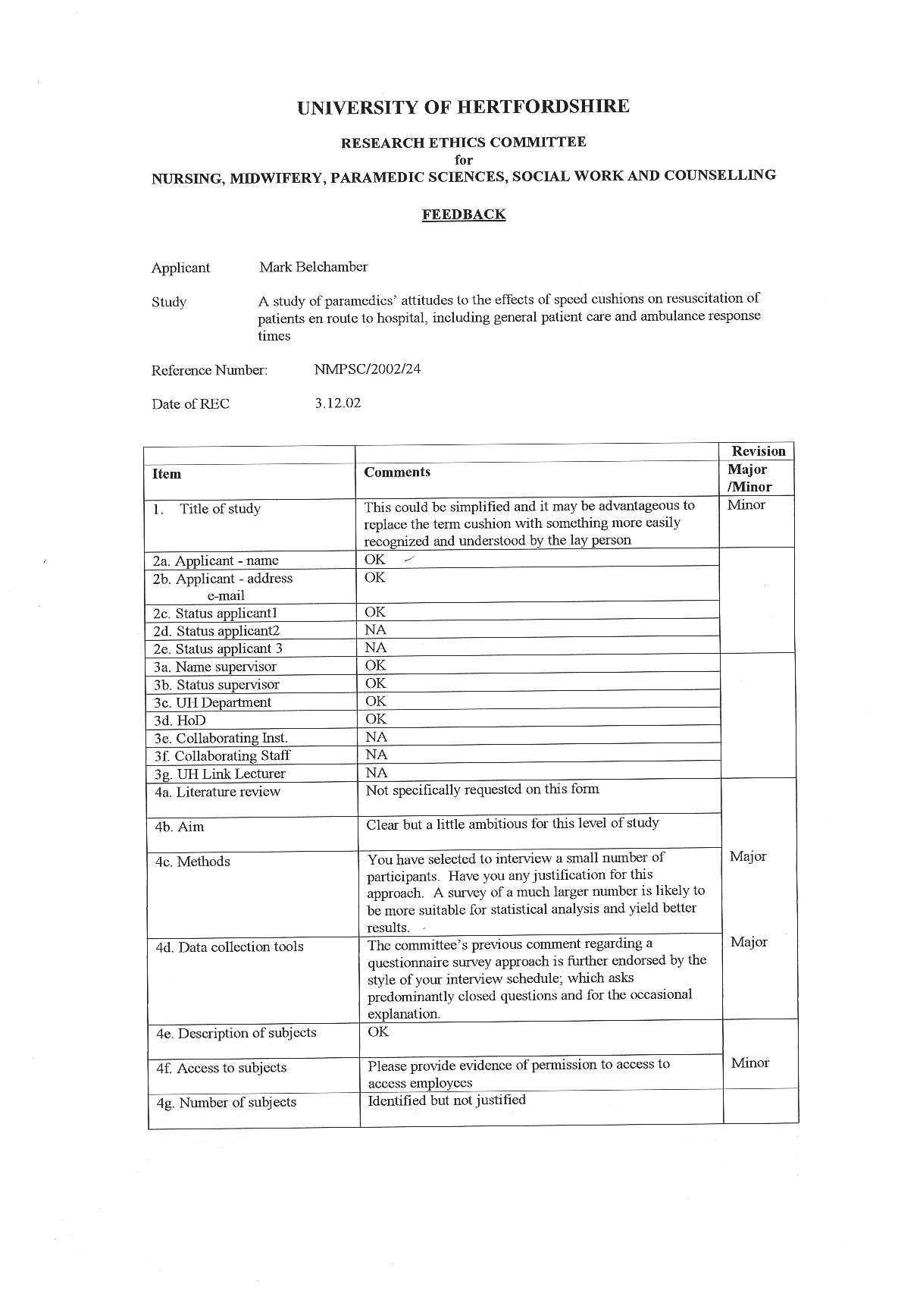
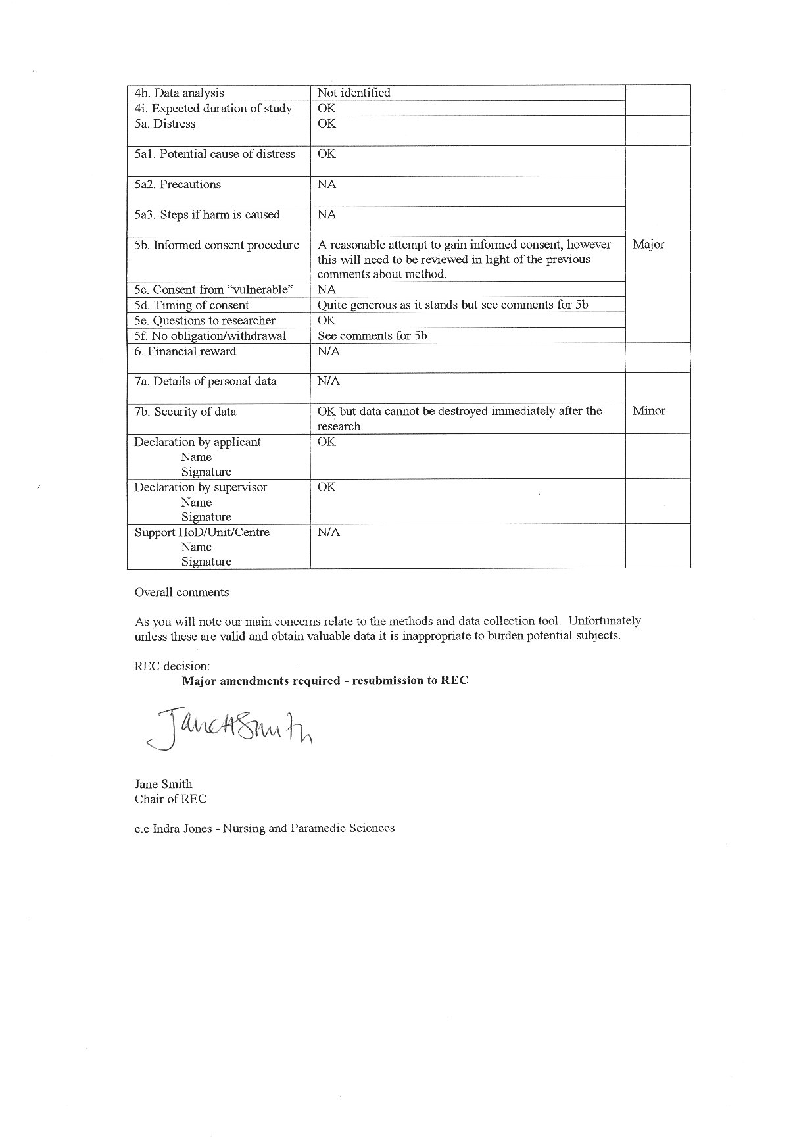

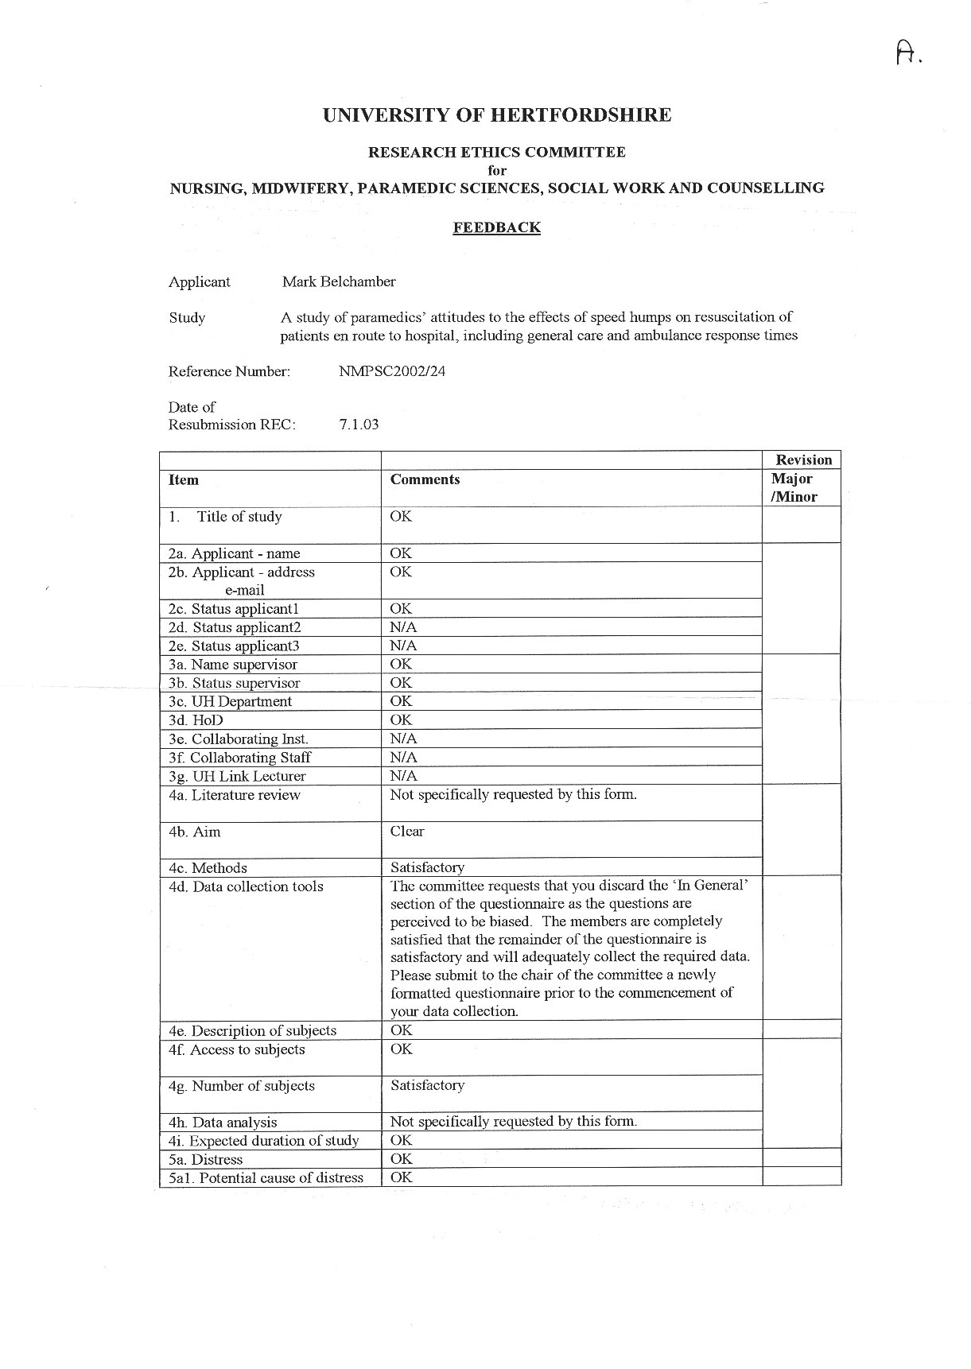

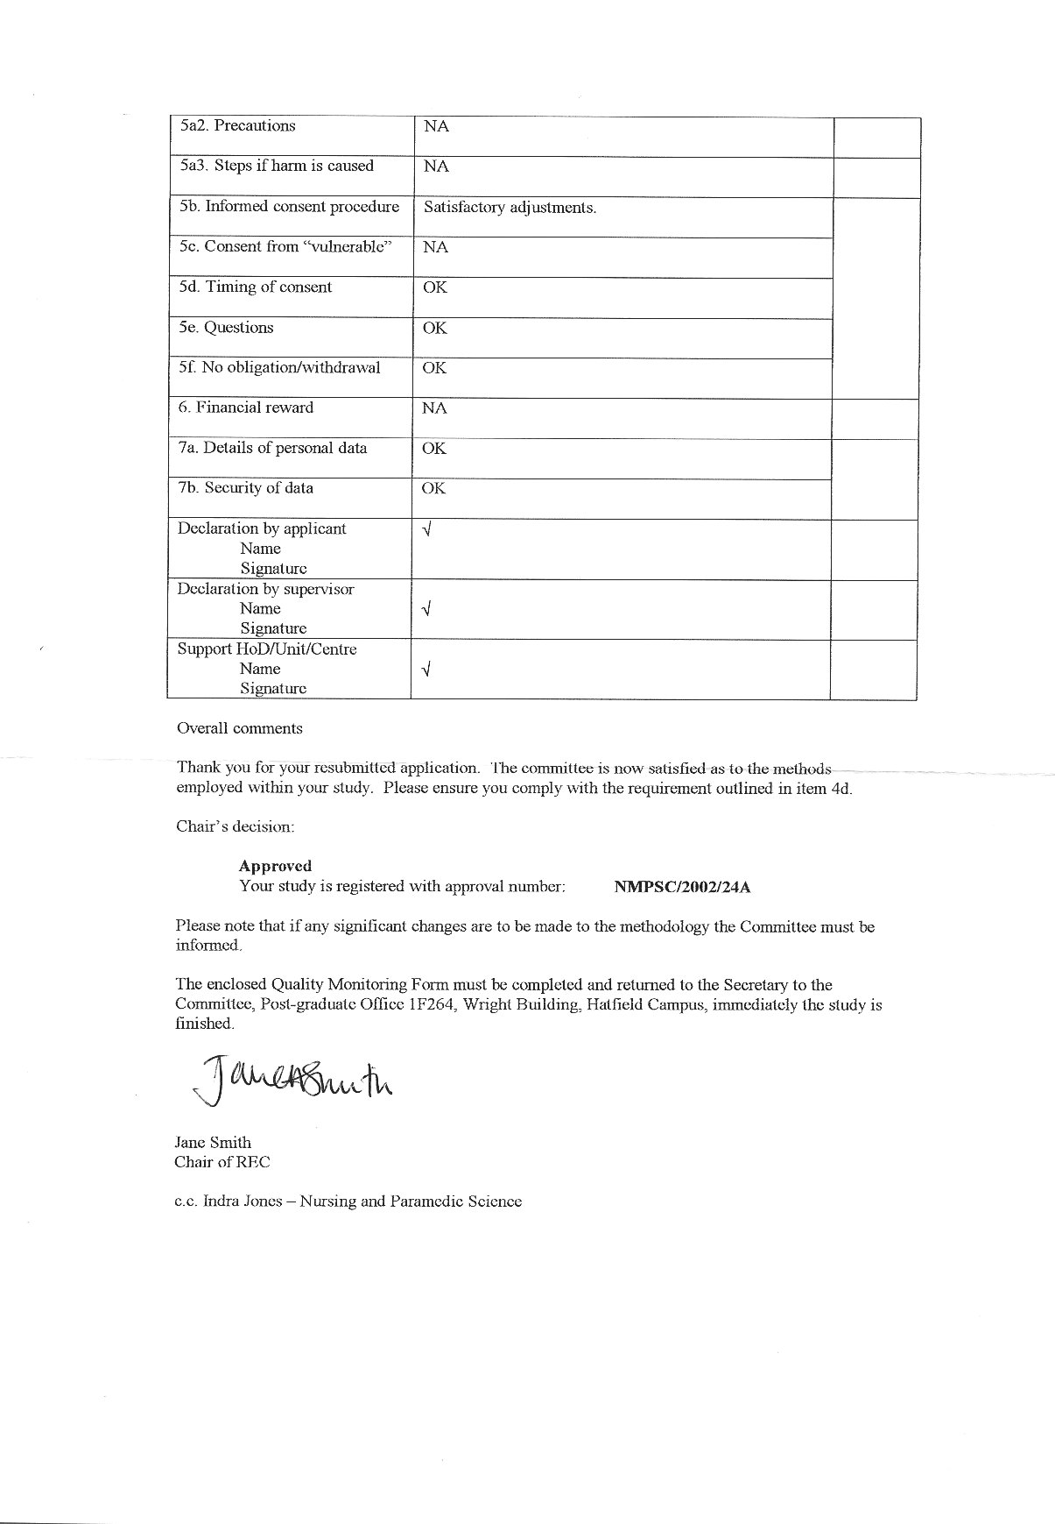
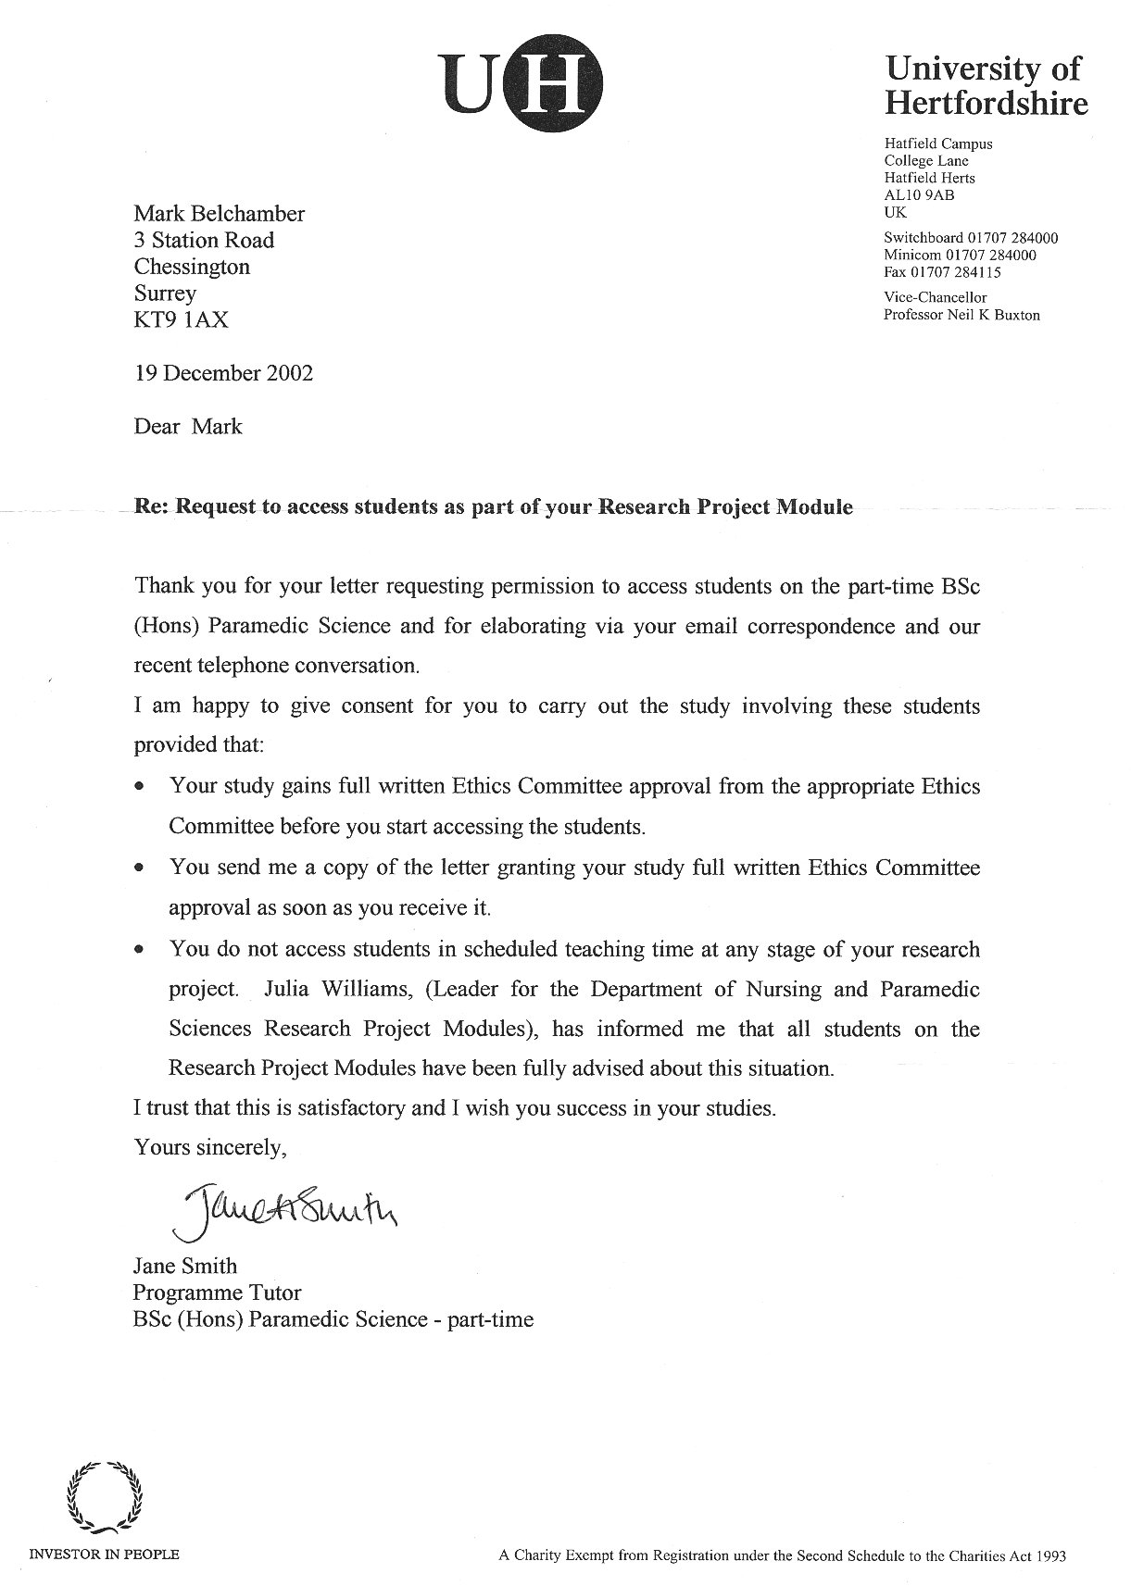

Appendix 4

Questionnaire pack

Information letter

Consent form

Questionnaire

Poster used as follow up

1 New Cross Road
Deptford
London

SE14 5DS

Dear Colleague,

I am Mark Belchamber, a final year degree student undertaking the BSc (Hons) in Paramedic Science at the University of Hertfordshire. As part of the final year I am required to conduct a research project – I have chosen to investigate:

A study of paramedics’ attitudes to the effects of speed humps on resuscitation of patients en route to hospital, including general patient care and ambulance response times.

The rationale for this particular research is to add to and inform practice as there is very little knowledge in this area concerning pre-hospital care and, ultimately, to improve patient care and outcome.

For this purpose I am seeking your co-operation to complete the enclosed questionnaire on the above subject.

Your participation is entirely voluntary and you are free to withdraw at any time without reason and without prejudice. Above is my address and below are my contact numbers. These details may be used in the event that you would like any further information, clarification, and/or support at any stage.

Additionally the questionnaires are coded so that if you return your questionnaire and later decide you would not like it to be used as part of the study, you can use the contact details and quote the number on your questionnaire, which will be destroyed immediately. This option is open to you at any point until end of March 2003.

All paperwork and will be kept strictly confidential and under lock and key, and all computerised data will only be kept on removable, password protected media. It will only be used by me as the researcher for this project and may only be seen by my academic mentor and me.

Anonymity is guaranteed and your name will not be used in any literature, either transcript or final write-up.

Thank you for your initial interest into my research on this subject – if you have any questions please do contact me.

Mark Belchamber
020 7639 5750 – Office
07789 504 717 – Mobile (work)
Consent Form

A study of paramedics’ attitudes to the effects of speed humps on resuscitation of patients en route to hospital, including general patient care and ambulance response times.

Dear Colleague,

Thank you for agreeing to take part in this research project. Please read the statements below, sign at the bottom if you give your consent to the contents and return in the enclosed envelope with your completed questionnaire no later than 28th March 2003.

I am fully aware of the aims of this research and I give my consent to my information regarding this research to be used. I am aware of the fact that I can withdraw my co-operation with this research without explanation and without prejudice at any time.

I have contact details that can be used to request withdrawal from the research until March 2003 (when it is anticipated that the details will start to be used to form the body of the research). These details may also be used in the event that I need any further information, clarification, and/or support.

I understand that all copies of the questionnaire will be kept in a locked cabinet. I am aware that any computerised records will be removable (e.g. floppy or zip disk) and will be similarly stored. No names will be recorded anywhere, although to facilitate future possible withdrawal I consent to numbers being used to identify my paper that could be cross referenced to my name if required. This information will be destroyed in March 2003. I give my consent that the only other person to see any raw data will be the interviewer’s academic mentor.

Signature…………………………..

A study of paramedics’ attitudes to the effects of speed humps on
resuscitation of patients en route to hospital, including general
patient care and ambulance response times.

Questionnaire

Please circle the appropriate answer

- How many calls (average) do you do per shift?
1-4 5-9 10-14 14+

a) For approximately how many of those calls do you have to travel on roads with speed humps in?
1-4 5-9 10-14 14+

For each of the following statements, please circle the appropriate answer and explain where applicable

Responding to a call (emergency response) – blue lights and sirens

- On the way to a call (999 response), I would deliberately take a different route to avoid speed humps:

YES / NO

- Please explain

b) If YES, how many minutes extra travelling time would you consider to be acceptable to avoid the humps:
______ minutes

Responding to a call (non emergency response) – NO blue lights and sirens

- On the way to a call I would deliberately take a different route to avoid speed humps?
YES / NO

- Please explain

b) If YES, how many minutes extra travelling time would you consider to be acceptable to avoid the humps?
______ minutes

In the ambulance with a patient

- Given a patient whose condition is stable, I would deliberately take a different route to the receiving facility to avoid speed humps:
YES / NO

- Please explain

b) If YES, how many minutes extra travelling time would you consider to be acceptable to avoid the humps?
______ minutes

Please circle the appropriate answer and explain where applicable

- Have any patients ever commented to you about speed humps whilst in your care in the ambulance?
OFTEN / SOMETIMES / RARELY / NEVER

- What did they say?

Please give your response to the following statements:

- Given a patient whose condition is unstable, I would deliberately take a different route to the receiving facility to avoid speed humps:
YES / NO

- Please explain

- If YES, how many minutes extra travelling time would you consider to be acceptable to avoid the humps?
______ minutes

- Given a patient who is in cardiac arrest, I would deliberately take a different route to the receiving facility to avoid speed humps:
YES / NO

- Please explain

b) If YES, how many minutes extra travelling time would you consider to be acceptable to avoid the humps?
______ minutes

- Have you ever had to resuscitate a patient whilst travelling over road humps?
YES / NO

- If so, do you feel your CPR performance was affected?
YES / NO

- Please explain

f) Do you feel this affected the patient’s outcome?
YES / NO

g) Please explain

Please circle the appropriate answer and explain where applicable

- Do you feel that any specific types of patient condition are affected by road humps?
YES / NO

- Please explain

- Have you ever chosen not to undertake any procedure on a patient solely due to the presence of speed humps (i.e. on a smooth surface you would have undertaken that procedure)?
YES / NO

- If YES, please state which procedure and why.

b) Do you feel that this detracted from your patient care?
YES / NO

- Please explain

d) Was it an essential procedure?

THANK YOU FOR YOUR ASSISTANCE. PLEASE RETURN THIS QUESTIONNAIRE AND CONSENT FORM IN THE ENVELOPE PROVIDED. PLEASE KEEP MY DETAILS AND YOUR QUESTIONNAIRE NUMBER IN CASE YOU WISH TO WITHDRAW YOUR QUESTIONNAIRE BEFORE END OF MARCH 2003.

Appendix 5

Pre test results

Q1. Was the information letter clear and easy to understand, with all the relevant contact details and information?

 | Frequency | %
Yes | 10 | 100
No | 0 | 0

Q2. Was the consent form clear and easy to understand and appropriate to the research?

 | Frequency | %
Yes | 10 | 100
No | 0 | 0

Q3 Was the questionnaire clear and easy to answer?

 | Frequency | %
Yes | 10 | 100
No | 0 | 0

Q4. Were any of the questions ambiguous or difficult to answer?

 | Frequency | %
Yes | 0 | 100
No | 10 | 0

Q5. Please feel free to offer suggestions on improving the letter, consent form, or questionnaire.

One suggestion was made discouraging the use of a reminder header saying “Please return no later than 28th March 2003” on each page of the questionnaire.

This pre test shows that the questionnaire and associated forms were understood by all 10 respondents. The one other suggestion did not affect rigour.

References

Atschul A. and Sinclair H. (1981) Psychology For Nurses. 5th ed. London. Balliere Tindall.

Bandman E.L. and Bandman B. (1990) Nursing Ethics Through The Life Span. London. Prentice Hall

Benner P. (1984) From Novice To Expert. California. Addison Wesley.

Bassetlaw (2002) Lords Hansard Text http://www.publications.parliament.uk/pa/cm200102/cmhansrd/vo020703/halltext/20703h04.htm [6th January 2003]

Brake (1997) Lords Hansard Text http://www.publications.parliament.uk/pa/cm199798/cmhansrd/vo971105/debtext/71105-03.htm [6th January 2003]

Bunte L. Jr. (2000) Traffic Calming Programmes & Emergency Response: A Competition Of Two Public Goods. Unpublished BSc. Thesis. Austin, University of Texas.

Chapman P. (June 26th 2000) Show us the Way to go Home. The Evening News. 6.

Chope (1991) Lords Hansard Text http://www.parliament.the-stationery-office.co.uk/pa/cm199091/cmhansrd/1991-01-14/Orals-1.html [6th January 2003]

City of Berkeley (1995) Letter Report by Berkeley, California, Fire and Emergency Services Department. Berkeley. Department of Fire and Emergency Services

City Council of Boulder, Colorado (1997) Deaths Expected from Delayed Emergency Response Due to Neighborhood Traffic Mitigation. Colorado. Ronald R Bowman

Clement J (1995) My Experience With Speed Humps. Unpublished report.

Cole G. (1996) Management Theory And Practice. 5th Ed. London. Letts Educational.

Cormack D. (1996) The Research Process In Nursing. 3rd ed. Oxford. Blackwell Science

Dean B. (1998) Stress : Perspectives and Processes. Buckingham. Open University Press

Great Britain. Department of Heath (1998) National Service Framework for Coronary Heart Disease. London. HMSO.

Great Britain. Parliament (2000) The NHS Plan. A Plan for Investment, a Plan for Reform. London. HMSO.

References (Continued)

Jones S. (January 1st 2001) Intelligent Road Hump Brings Traffic Calm to Careful Drivers. Financial Times. 14.

Lachman V. (1983) Stress Management: A Manual For Nurses. Philadelphia. WB Saunders Company

Lincoln Y.S. and Guba E. (1985) Naturalistic Enquiry. Beverly Hills. Sage.

London Ambulance Service (1991) Ambulance Service Basic Training. Bristol. Swindon Press Ltd.

Montgomery County Fire & Rescue Commission (1997) The effects of Speed Humps and Traffic Circles on Responding Fire-Rescue Apparatus in Montgomery County, MD. Maryland. Fire and Rescue Commision.

National Motorists Association http://www.motorists.org/issues/engineering/battling_traffic_calming.htm [6th January 2003]

Oppenheim A. (1992) Questionnaire Design, Interviewing And Attitude Measurement. London. Pinter Publishers

Parahoo K. (1997) Nursing Research. Macmillan. London

Polgar S. and Thomas S.A. (1995) Introduction to Research in the Health Sciences. London. Churchill Livingstone

Polit D.F. and Hungler B.P. (1999) Nursing Research: Principles and Methods. 6th ed. Philadelphia. Lippincott.

Reinton, S. (27th February 2001) (personal communication)

Schwartz S. and Griffin T. (1986) Medical Thinking: The Psychology Of Medical Judgement And Decision Making. New York. Springer-Verlag

Sullivan E. and Decker P. (1997) Effective Leadership And Management In Nursing. 4th ed. New York. Addison-Wesley.

Sullivan K. (1996) Experiences With A Volunteer Sample. Nurse Researcher. 3. (4): 69-76

Tarling M. and Crofts L. (Eds.) (1998) The Essential Researcher’s Handbook For Nurses And Healthcare Professionals. London. Balliere Tindall

United Kingdom. Statutory Instrument (1993) The Highways (Traffic Calming) Regulations. London. HMSO. (S.I. No. 1849)

Walsh M. (2001) Research Made Real. Cheltenham. Nelson Thornes Ltd.
Bibliography

Americans for Traffic Calming Reform http://www.io.com/~bumper/ada0037.htm [6th January 2003]

Burnard P. (1991) A Method of Analysing Interview Transcripts in Qualitative Research. Nurse Education Today. 11. 461-465.

Burnard P. (1994) Searching for a meaning: A Method of Analysing Interview Transcripts with a Personal Computer. Nurse Education Today. 14. 111-117.

Cars Against Road-Hump Madness http://www.users.globalnet.co.uk/~cavok/hump.html [6th January 2003]

Colorado Daily, On-Line http://www.speedhumps.com/SIDE12E.html [6th January 2003]

Department of Transport (1994) Fire and Ambulance Services Traffic Calming: A Code of Practice. London. DOT

Department of the Environment, Transport and the Regions (1994) Traffic Advisory Unit: Speed cushions. London. DETR

Department of the Environment, Transport and the Regions (1998) Traffic Advisory Unit: Sinusoidal, “H” & “S” Road humps. London. DETR

Emergency Vehicle Response Time Adversely Affected http://www.speedhumps.com/malibu.htm [6th January 2003]

Lords Hansard Text http://www.parliament.the.stationary-office.co.uk/pa/ld199900/lhhansard/vo001116/text.html [6th January 2003]

Morse J.M. and Field P.A. (1996) Nursing Research: The Application of Qualitative Approaches. 2nd ed. Cheltenham. Stanley Thornes.

Oldham J.A. (1993) Statistical Tests (Part 2): Parametric Tests. Nursing Standard. 7. (44): 28-30

Road Access for Disabled Americans http://www.digitalthreads.com/rada/ [6th January 2003]

Rubin H.J. and Rubin I.S. (1995) Qualitative Interviewing. London. Sage

Strongman K. (1979) Psychology for the Paramedical Professionals. London. Croom Helm

The Evidence is Clear http://www.speedhumps.com/Fire Emergency.htm [6th January 2003]

Bibliography (Continued)

Traffic Calming http://www.civl.port.ac.uk/comp_prog/traffic/intro.html [6th January 2003]

United Kingdom. Statutory Instrument (1990) The Highways (Road humps) Regulations. London. HMSO. (S.I. No. 703)

United Kingdom. Parliament (1980) The Highways Act. London. HMSO.

United Kingdom. Parliament (1992) Traffic Calming Act. London. HMSO.

Wokingham District Council (2001) Wokingham District Deposit Draft Local Plan 1996-2006, With Proposed Amendments. Wokingham. WDC.

